**PREPARED BY:** **GUIDED BY:**

VASU PATEL(CE-093) PROF. J. M. Pandya(Assistant Prof.)

DHRUVIT PAREKH(CE-082)

PRASHIT PATEL(CE-090)

INDEX

1. Project Overview………………………..

2. E .R. Diagram…………………………….

3. Database Schema/TABLE Definition……..

4. Implementation………………………….

5.Index and Views…………………………

6. SRS Queries…………………………………..

7. Reports……………………………………

8. Deployment Steps……………………..

9.Oracle Features Summary………………

PROJECT OVERVIEW

Online Betting System provides users who are interested in cricket and really want to watch their dream team to play in real , The FANTASY BUZZ is an online cricket betting website that allows all users to create their own teams & compete . Unlike other betting websites , our product allows users to play for each international matches & they also shows who are in leader in this thrilling competition .

**Goals:-**

-To add more entertainment towards the game of cricket.

-To show expertise on selection of complete team to other users.

**Scopes:-**

-Participation will be available for all real cricket matches.

-Updation of scores will be available only after completion of match.

**Features:-**

-Create your own league & compete with your friends.

-GUI would be easier to manage your team.

-Individual points of each player will be shown in the result.

|  |  |
| --- | --- |
| *Terms* | *Definition* |
| *Events* | *Upcoming matches between 2 teams.* |
| *League* | *All participants will take part in it and through this league winners will be decided.* |
| *Guide page* | *By which user comes to know about conditions and how points will be given to the participants.* |
| *User* | Reviewer or Author. |
| *Member* | *User who participates in the event* |

ER DIAGRAM

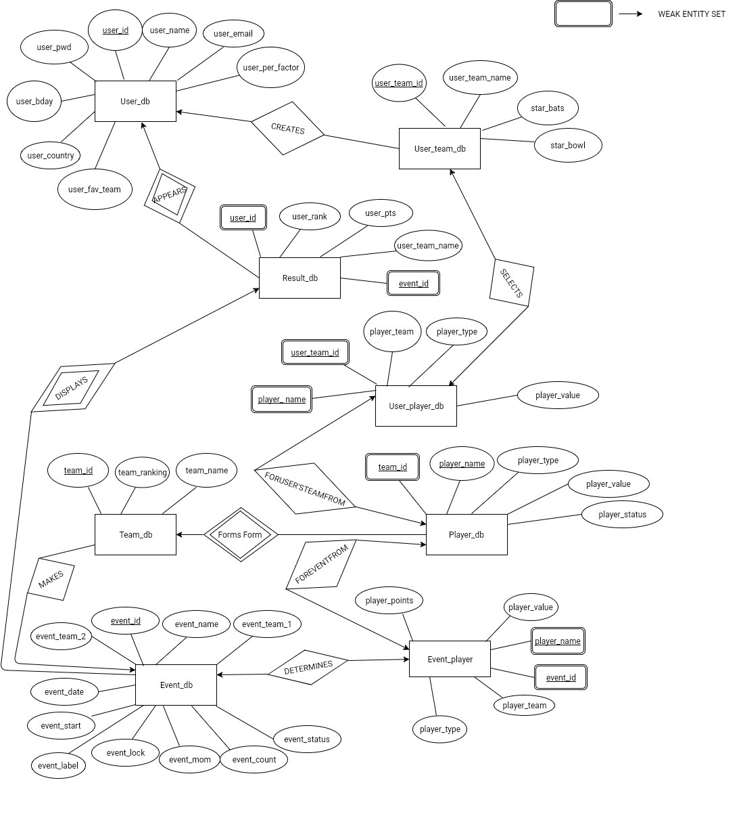

**SCHEMA DIAGRAM**

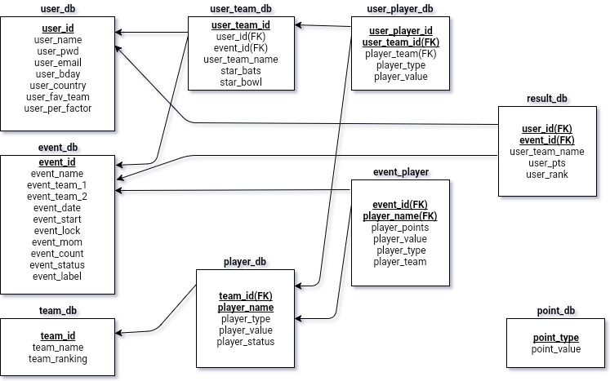

**IMPLEMENTATION**

**TABLE CREATION**

**CREATE USER_DB TABLE:-**

CREATE TABLE user_db (

user_id INT IDENTITY(1,1) PRIMARY KEY,

user_name VARCHAR2(50) UNIQUE NOT NULL ,

user_pwd VARCHAR2(50) NOT NULL,

user_email VARCHAR2(50) UNIQUE NOT NULL,

user_bday DATE ,

user_country VARCHAR2(50),

user_fav_team VARCHAR2(50),

user_per_factor NUMBER(4,2) default(0)

);

INSERT INTO user_db(user_id ,user_name,user_pwd,user_email,user_bday,user_country,user_fav_team,user_per_factor) VALUES (0001,vasu,vasu123,vasu98@gmail.com,”06/02/1998”,”INDIA”,”INDIA”,0.0);

|  |  |  |  |
| --- | --- | --- | --- |
| **COLUMN NAME** | **DATATYPE** | **SIZE** | **ATTRIBUTE** |
| user_id | INT |  | PRIMARY KEY |
| user_name | VARCHAR2 | 50 | UNIQUE |
| user_pwd | VARCHAR2 | 50 | NOT NULL |
| user_email | VARCHAR2 | 50 | UNIQUE |
| user_bday | Date |  | NULL |
| user_country | VARCHAR2 | 50 | NULL |
| user_fav_team | VARCHAR2 | 50 | NULL |
| user_per_factor | Float |  | BY DEFAULT ‘0’ |

**CREATE TEAM_DB TABLE:-**

CREATE TABLE team_db (

team_id INT IDENTITY(1,1) PRIMARY KEY ,

team_name VARCHAR2(50) UNIQUE,

team_ranking INT UNIQUE ,

);

INSERT INTO team_db (team_id,team_name,team_ranking) VALUES (001,”INDIA”,1);

INSERT INTO team_db (team_id,team_name,team_ranking ) VALUES (002,”SOUTH AFRICA”,2);

|  |  |  |  |
| --- | --- | --- | --- |
| **COLUMN NAME** | **DATATYPE** | **SIZE** | **ATTRIBUTE** |
| team_id | INT |  | PRIMARY KEY |
| team_name | VARCHAR2 | 50 | UNIQUE |
| team_ranking | INT |  | UNIQUE |

**CREATE PLAYER_DB TABLE:-**

CREATE player_db(

team_id INT ,

player_name VARCHAR2(50),

player_type VARCHAR2 (50),

player_value NUMBER(2,2) ,

player_status VARCHAR2 (50),

PRIMARY KEY ( team_id , player_name )

FOREIGN KEY (team_id) REFERENCES team_db(team_id),

CHECK ( player_status like ‘unavailable’ OR player_status like ‘available’)

CHECK ( player_value < 11.0 )

CHECK ( player_type LIKE ‘batsman’ OR player_type LIKE ‘bowler’ OR player_type LIKE ‘allrounder’)

);

INSERT INTO player_db ( team_id , player_name , player_type , player_value , player_status) VALUES (001,”VIRAT KOHLI” , ”BATSMAN” , 10.0 , “AVAILABLE” );

INSERT INTO player_db ( team_id , player_name , player_type , player_value , player_status) VALUES (004,”STEVE SMITH” , ”BATSMAN” , 10.0 , “AVAILABLE” );

|  |  |  |  |
| --- | --- | --- | --- |
| **COLUMN NAME** | **DATATYPE** | **SIZE** | **ATTRIBUTE** |
| team_id | INT |  | FOREIGN KEY TEAM_DB,PRIMARY KEY |
| player_name | VARCHAR2 | 50 | PRIMARY KEY |
| player_type | VARCHAR2 | 50 | NULL |
| player_value | VARCHAR2 |  | NULL |
| player_status | VARCHAR2 | 50 | NULL |

**CREATE EVENT_DB TABLE:-**

CREATE TABLE event_db (

event_id INT PRIMARY KEY,

event_name VARCHAR2(50),

event_team1 VARCHAMAR2(50),

event_team2 VARCHAR2(50),

event_date date,

event_start time_stamp,

event_lock time_stamp,

event_mom varchar2(50),

event_count INT DEFAULT ‘0’,

event_status VARCHAR2(50) NULL,

event_label VARCHAR2,

FOREIGN KEY (event_team_id1) REFERENCES team_db(team_name),

CHECK ( event_status LIKE ‘open’ OR event_status LIKE ‘hidden’ OR event_status LIKE ‘locked’ OR event_status LIKE ‘closed’ )

FOREIGN KEY (event_team_id2) REFERENCES team_db(team_name),

CHECK(event_lock > event_start),

);

INSERT INTO event_db (event_id , event_name , event_team_1 , event_team_2 , event_date, event_start , event_lock , event_count,event_status ) VALUES (1,”indiavsnewzealand”, “INDIA”, “NEWZEALAND” , 18-11-2017 01:00, 19-11-2017 11:00 , 0 , “HIDDEN” );

|  |  |  |  |
| --- | --- | --- | --- |
| **COLUMN NAME** | **DATATYPE** | **SIZE** | **ATTRIBUTE** |
| event_id | INT |  | PRIMARY KEY |
| event_label | VARCHAR2 | 50 | NULL |
| event_team_1 | VARCHAR2 | 50 | NULL |
| event_team_2 | VARCHAR2 | 50 | NULL |
| event_date | DATE |  | NULL |
| event_start | Time_stamp |  | NOT NULL |
| event_lock | Time_stamp |  | NOT NULL |
| event_mom | VARCHAR2 | 50 | NOT NULL |
| event_count | INT |  | BY DEFAULT ‘0’ |
| event_status | VARCHAR2 | 50 | NOT NULL |

**CREATE EVENT_PLAYER_DB TABLE:-**

CREATE TABLE event_player_db(

event_id INT ,

player_name VARCHAR2(50),

player_points NUMBER(2,2),

player_value NUMBER(2,2) NOT NULL,

player_type VARCHAR2(50) ,

player_team VARCHAR2(50),

PRIMARY KEY(event_id,player_name),

FOREIGN KEY (player_id) references player_db(player_id),

FOREIGN KEY(player_name) references player_db(player_name)

);

INSERT INTO event_player_db (event_id , player_name , player_points , player_values , player_type , player_team ) VALUES (1,”VIRATKOHLI”, 0, 10.5 , “BATSMAN” , “INDIA” );

|  |  |  |  |
| --- | --- | --- | --- |
| **COLUMN NAME** | **DATATYPE** | **SIZE** | **ATTRIBUTE** |
| event_id | INT |  | FOREIGN KEY EVENT_DB |
| Player_name | VARCHAR2 | 50 | FOREIGN KEY PLAYER_DB |
| player_points | NUMBER |  | BY DEFAULT ‘0’ |
| player_value | NUMBER |  | NOT NULL |
| player_type | VARCHAR2 | 50 |  |
| Player_team | VARCHAR2 | 50 |  |

**CREATE USER_TEAM_DB TABLE:-**

CREATE TABLE user_team_db(

event_id INT ,

user_id INT ,

user_team_id INT PRIMARY KEY

user_team_name VARCHAR2(50) ,

star_bats VARCHAR2(50),

star_bowl VARCHAR2(50),

FOREIGN KEY (user_id) references user_db(user_id),

FOREIGN KEY (event_id) references event_db(event_id)

);

INSERT INTO user_team_db (event_id , user_id , user_team_name , user_team_id , star_bats , star_bowl ) VALUES (1,0001,”strikers11” , 0101 , “VIRAT KOHLI” , “JASPRIT BUMRAH” );

INSERT INTO user_team_db (event_id , user_id , user_team_name , user_team_id , star_bats , star_bowl ) VALUES (1,0001,”SUPER11” , 0105 , “ROHIT SHARMA” , “AXAR PATEL” );

|  |  |  |  |
| --- | --- | --- | --- |
| **COLUMN NAME** | **DATATYPE** | **SIZE** | **ATTRIBUTE** |
| user_team_id | INT |  | PRIMARY KEY |
| event_id | INT |  | FOREIGN KEY EVENT_DB |
| user_id | INT |  | FOREIGN KEY USER_DB |
| user_team_name | VARCHAR2 | 50 | NOT NULL |
| star_bats | VARCHAR2 | 50 |  |
| star_bowl | VARCHAR2 | 50 |  |

**CREATE USER_PLAYER TABLE:-**

CREATE TABLE user_palyer (

user_team_id INT ,

player_name VARCHAR2(50) ,

player_team VARCHAR2(50) NOT NULL,

player_type VARCHAR2(50) ,

player_value NUMBER(2,2),

PRIMARY KEY (user_team_id,player_name),

FOREIGN KEY (player_name) references player_db(player_name),

FOREIGN KEY (user_team_id) references user_team_db(user_team_id),

FOREIGN KEY (player_team) references team_db(team_name),

);

INSERT INTO user_player_db (user_team_id , player_name , player_team , player_type , player_value ) VALUES (0101,”VIRATKOHLI” , “INDIA” , “BATSMAN” ,”viratkohli” , 10.5 );

|  |  |  |  |
| --- | --- | --- | --- |
| **COLUMN NAME** | **DATATYPE** | **SIZE** | **ATTRIBUTE** |
| user_team_id | INT |  | FOREIGN KEY USER_TEAM_DB |
| player_name | VARCHAR2 | 50 | FOREIGN KEY PLAYER_DB |
| player_team | VARCHAR2 | 50 |  |
| player_type | VARCHAR2 | 50 |  |
| player_value | NUMBER |  |  |

**CREATE RESULT_DB TABLE:-**

CREATE TABLE result_db(

event_id INT ,

user_id INT ,

user_team_name VARCHAR2(50),

user_pts float(53) default(0) ,

user_rank INT default(1),

PRIMARY KEY ( event_id , user_id )

FOREIGN KEY (event_id) REFERENCES event_db(event_id),

FOREIGN KEY (user_id) REFERENCES user_db (user_id)

);

INSERT INTO result_db (event_id , user_id , user_team _name , user_pts , user_rank ) VALUES (1,0001,”strikers11” , 115 , 7 );

INSERT INTO result_db (event_id , user_id , user_team _name , user_pts , user_rank ) VALUES (2,0001,”super11” , 225 , 1,10009 );

|  |  |  |  |
| --- | --- | --- | --- |
| **COLUMN NAME** | **DATATYPE** | **SIZE** | **ATTRIBUTE** |
| user_id | INT |  | FOREIGN KEY USER_DB |
| event_id | INT |  | FOREIGN KEY EVENT_DB |
| user_team_name | VARCHAR2 | 50 | NULL |
| user_pts | NUMBER |  | NULL |
| user_rank | INT |  | NULL |

**CREATE POINT_DB TABLE:-**

CREATE TABLE point_db (

Point_type varchar2(50) PRIMARY KEY,

Point_value NUMBER(2)

);

INSERT INTO point_db (point_type,point_value) VALUES (”RUNS”,1);

INSERT INTO point_db (point_type,point_value) VALUES (”DUCK”,-5);

INSERT INTO point_db (point_type,point_value) VALUES (”FOUR”, 5);

INSERT INTO point_db (point_type,point_value) VALUES (”SIX”,10);

INSERT INTO point_db (point_type,point_value) VALUES (”FIFTY”,20);

INSERT INTO point_db (point_type,point_value) VALUES (”CENTURY”,30);

INSERT INTO point_db (point_type,point_value) VALUES (”WICKET”,20);

INSERT INTO point_db (point_type,point_value) VALUES (”MAIDEN”,5);

INSERT INTO point_db (point_type,point_value) VALUES (”RUNS GIVEN”,-0.25);

INSERT INTO point_db (point_type,point_value) VALUES (”FIVE WICKET ”, 30 );

INSERT INTO point_db (point_type,point_value) VALUES (”MOM ”, 50 );

|  |  |  |  |
| --- | --- | --- | --- |
| **COLUMN NAME** | **DATATYPE** | **SIZE** | **ATTRIBUTE** |
| Point_type | VARCHAR2 | 50 | PRIMARY KEY |
| Point_value | NUMBER | 2 |  |

**Indexes And Views**

Index1

# Index on event_player table on event_id and player_team.

**Create index eve_team_player on event_player(event_id,player_team);**

**Index 2**

# Index on user_team_db table on event_id.

**Create index eve_user on user_team_db(event_id);**

Index 3

# Index on user_player_db on user_team_id.

**Create index user_team on user_player_db(user_team_id);**

**View1**

# View to see players available for selection for current event.

**Create view available_players as select * from player_db where player_status='available' and team_id in (select team_id from team_db where team_name in (select event_team1 from event_db where event_id=1) OR team_name in (select event_team2 from event_db where event_id=1));**

View2

# View for user to see his/her team after creation.

**Create view my_team as select * from user_player_db where user_team_id in (select user_team_id from user_team_db where user_id=0001 and event_id=1);**

**SRS Queries**

**4.1***:****System allows admin to manage events.***

**i/p:-event_info**

**o/p:-updated_info**

**des:-System takes information about teams,time etc regarding the event and allows admin to manage that event.**

*4.1.1 System allows admin to CREATE the event.*

i/p:-event_info

o/p:-updated_event_info

des:-System CHECKs for valid teams in master_TABLE & CREATEs event & make event visible to users.

Query:- INSERT INTO event_db (event_id,event_team1,event_team2,event_date,event_start,event_lock,event_count,event_status,event_label) VALUES (1,'INDIA','NEW ZEALAND','08/11/2017','08/11/2017 01:00:00','08/11/2017 7:00:00' , 0 , 'locked','3rd T20');

*4.1.2 System allows admin to edit event.*

i/p:- event_info

o/p:- updated_event_info

des:-System updates the event info as specified by the user.

Query:-update event_id set *[updated_attribute]*=*”new value”* where event_id=1;

Eg.-

To update event_date: update event_db set event_date=10-11-2017 where event_id=1;

*4.1.3 System allows admin to delete event.*

i/p:-event_info

o/p:-updated_event_info

des:-System deletes the event from database as and when required by the admin and makes it invisible for the users.

Query:- delete * from event_db where event_id=1;

## *4.2:-System provides selection of players from 2 teams playing the match with max. 6 players from 1 team.*

**i/p:-Players from participating team**

**o/p:-Final CREATEd team**

**dec:-System provides all the players list from 2 participating teams in the event and allows user to CREATE his team from it.**

*4.2.1 System provides event_TABLE from master_TABLE of players for 2 teams.*

i/p:-master_TABLE of players

o/p:-event_TABLE

des:-System will CREATE team TABLE for the event from master_TABLE of players & makes visible to users.

Query: select p.*,t.team_name from player_db p,team_db t where p.player_status='available' and t.team_id in (select team_id from team_db where team_name in (select event_team1 from event_db where event_id=1) OR team_name in (select event_team2 from event_db where event_id=1));

*4.2.2 System will validate the team on creation by user.*

i/p:-event_TABLE

o/p:-(valid)team_TABLE

des:-System will count for total 11 players & max. 6 from each & validates the team.

Query:-select count(*) from user_player_db where user_team_id in (select user_team_id from user_team_db where user_id=0001 and event_id=1);

select count(*) from user_player_db where user_team_id in (select user_team_id from user_team_db where event_id=1 and user_id=1) group by(player_team);

*4.2.3 System allows user to CREATE 1 star batsman & 1 star bowler.*

i/p:-(valid)team_TABLE

o/p:-star_batsman_flag=true and star_bowler_flag=true

des:-System will mark the star batsman & star bowler enter by the user.

Query:-update user_team_db set star_bats=’Virat Kohli’ and star_bowl=*’*JASPRIT BUMRAH*’* where user_id=0001;

*4.2.4 System displays the final team to the user.*

i/p:-(valid)team_TABLE

o/p:-team_visible_flag=true

des:-System CHECKs team _TABLE if it is valid,it displays the team otherwise error message.

Query:- select * from user_player_db where user_team_id in (select user_team_id from user_team_db where user_id=0001 and event_id=1);

*4.2.5 System provides option to edit the team.*

i/p:-(valid)team_TABLE

o/p:-changed (valid)team_TABLE

des:-System changes the players edited by the user & CHECKs for valid team.

Query:-update user_player_db set player_name=’ROHIT SHARMA’,

player_team=’INDIA’,player_type=’batsman’*,*  where user_team_id in (select user_team_id from user_team_db where user_id=0001 and event_id=1);

*4.2.6 System lock the final valid team_TABLE.*

i/p:-(valid)team_TABLE

o/p:-team_lock_flag=true

des:-System compares system time & event time if same,it locks the team.

Query:- update event_db set event_status=’locked’ where event_id=1;

## *4.3:-PoINTs will be given to players according to his runs and/or wickets & there will be no poINTs given for abandoned match.*

**i/p(valid)team_TABLE**

***o/p:-result_TABLE***

***des:-System gives poINTs to the submitted team after completion of match and gives the final result.***

*4.3.1 System allocates poINTs to individual players from each team.*

i/p:-(valid)team_TABLE

o/p:-total poINTs

des:-System will allocate poINTs to each player & add each of them to calculate total poINTs per each team.

*4.3.1.1 System allocates poINT to batsman.*

i/p:-(valid)team_TABLE

o/p:-poINTs of batsman

des:-System allocates -5 for duck,1 poINT for each run,5 poINTs for each boundary,10 poINTs for each six,20 poINTs for half century & 30 poINTs for century to each batsman from team_TABLE.

Query:-

**IF BATSMAN OUT FOR DUCK** : UPDATE RESULT_DB SET USER_PTS=(SELECT POINT_VALUE FROM POINT_DB WHERE POINT_TYPE=’DUCK’) WHERE USER_ID=0001 AND EVENT_ID=1;

**IF BATSMAN TAKES ONE RUN** : UPDATE RESULT_DB SET USER_PTS=(SELECT POINT_VALUE FROM POINT_DB WHERE POINT_TYPE=’RUNS’) WHERE USER_ID=0001 AND EVENT_ID=1;

**IF BATSMAN HIT BOUNDARY** : UPDATE RESULT_DB SET USER_PTS=(SELECT POINT_VALUE FROM POINT_DB WHERE POINT_TYPE=’FOUR’) WHERE USER_ID=0001 AND EVENT_ID=1;

**IF BATSMAN HIT SIX** : UPDATE RESULT_DB SET USER_PTS=(SELECT POINT_VALUE FROM POINT_DB WHERE POINT_TYPE=’SIX’) WHERE USER_ID=0001 AND EVENT_ID=1;

**IF BATSMAN SCORES HALFCENTURY** : UPDATE RESULT_DB SET USER_PTS=(SELECT POINT_VALUE FROM POINT_DB WHERE POINT_TYPE=’FIFTY’) WHERE USER_ID=0001 AND EVENT_ID=1;

**IF BATSMAN SCORES CENTURY**  : UPDATE RESULT_DB SET USER_PTS=(SELECT POINT_VALUE FROM POINT_DB WHERE POINT_TYPE=’CENTURY’) WHERE USER_ID=0001 AND EVENT_ID=1;

*4.3.1.2 System allocates poINT to bowler.*

i/p:-(valid)team_TABLE

o/p:-poINTs of bowler

des:-System allocates 20 poINTs for each wicket,-0.25 for each run conceded,5 poINTs for maiden over & 30 poINTs for 5 wickets to each bowler from team_TABLE.

Query:-

**IF BOWLER TAKES WICKET** : UPDATE RESULT_DB SET USER_PTS=(SELECT POINT_VALUE FROM POINT_DB WHERE POINT_TYPE=’WICKET’) WHERE USER_ID=0001 AND EVENT_ID=1;

**IF BOWLER CONCEDES ONE RUN** : UPDATE RESULT_DB SET USER_PTS=(SELECT POINT_VALUE FROM POINT_DB WHERE POINT_TYPE=’RUN GIVEN’) WHERE USER_ID=0001 AND EVENT_ID=1;

**IF BOWLER BOWLED MAIDEN OVER** : UPDATE RESULT_DB SET USER_PTS=(SELECT POINT_VALUE FROM POINT_DB WHERE POINT_TYPE=’MAIDEN’) WHERE USER_ID=0001 AND EVENT_ID=1;

**IF BOWLER TAKES FIVE WICKETS** : UPDATE RESULT_DB SET USER_PTS=(SELECT POINT_VALUE FROM POINT_DB WHERE POINT_TYPE=’FIVE WICKETS’) WHERE USER_ID=0001 AND EVENT_ID=1; .

*4.3.1.3 System allocates extra poINTs for man of the match award.*

i/p:-(valid)team_TABLE

o/p:-poINTs to mom player

des:-System CHECKs for mom player to the team_TABLE & if present , allocates 25 poINTs.

Query:-

UPDATE RESULT_DB SET USER_PTS=(SELECT POINT_VALUE FROM POINT_DB WHERE POINT_TYPE=’MOM’) WHERE USER_ID=0001 AND EVENT_ID=1;

*4.3.1.4 System allocates bonus poINTs for star batsman & star bowler.*

i/p:-(valid)team_TABLE

o/p:-poINTs to star bowler & star batsman

des:-System doubles the existing poINTs for star bowler & star batsman.

Query:- UPDATE RESULT_DB SET USER_PTS=(select user_pts from result_db where USER_ID=1 AND EVENT_ID=1)+ (SELECT PLAYER_POINTS FROM EVENT_PLAYER_DB WHERE PLAYER_NAME IN (SELECT STAR_BATS FROM USER_TEAM_DB WHERE USER_ID=1 AND EVENT_ID=1)) WHERE USER_ID=0001 AND EVENT_ID=1;

UPDATE RESULT_DB SET USER_PTS=(select user_pts from result_db where USER_ID=0001 AND EVENT_ID=1)+ (SELECT PLAYER_POINTS FROM EVENT_PLAYER_DB WHERE PLAYER_NAME IN (SELECT STAR_BOWL FROM USER_TEAM_DB WHERE USER_ID=0001 AND EVENT_ID=1)) WHERE USER_ID=0001 AND EVENT_ID=1;

*4.3.1.5 System calculates total score.*

i/p:-(valid)team_TABLE

o/p:-total points

des:-System adds the poINTs of each player from the team_TABLE.

Query:- select user_pts from result_db where user_id=0001 and event_id=1;

*4.3.2 System CREATEs list of all participants.*

i/p:-team poINTs

o/p:-result_TABLE

des:-System CREATEs list of all the participated teams and sorts in descending order according to team poINTs.

Query:-

SELECT r.* FROM RESULT_DB r left outer join EVENT_DB e on r.EVENT_ID=e.event_id;

*4.3.3 System displays winning teams.*

i/p:-result_TABLE

o/p:-rank_TABLE

des:-System gives ranks to top 3 teams and displays the final results.

Query:-

SELECT EVENT_ID,USER_ID,USER_TEAM_NAME , USER_PTS, RANK() OVER (ORDER BY USER_PTS DESC) AS RANK FROM RESULT_DB where EVENT_ID=1;

Reports

REPORT 1

# See User Teams after event is locked.

* **Master Report**: See events when locked.

Select * from event_db where event_status=’locked’;

* **Sub Report 1** :See which users have created teams in the respective events by clicking on event row.

Select * from user_team_db where event_id=:EVENT_ID;

* **Sub Report 2**:See the selected users team on clicking on the user’s row.

Select * from user_player_db where user_team_id=:USER_TEAM_ID and event_id=:EVENT_ID;

REPORT 2

# See Results on completion of event.

* **Master Report:** See events when closed.

Select * from event_db where event_status=’closed’;

* **Sub Report 1** :See which results for the respective events by clicking on event row.

Select * from result_db where event_id=:EVENT_ID;

**Deployment steps :--**

1. Create user named OnlineBettingProject.

2. Grant all permission to user OnlineBettingProject.

3. Drop all tables if already exists in given order result_db , user_player_db , user_team_db , event_player_db , event_db, player_db , team_db , user_db.

6. Create all tables in given order user_db , team_db , player_db , event_db , event_player_db, user_team_db , user_player_db , result_db.

5. Drop all sequences if already exists in given order result_id , user_player_id , user_team_id , table_id , event_id, player_id , team_id , user_id .

6. Create all sequences user_id , team_id, player_id , event_id , table_id , user_team_id , user_player_id , result_id .

7. Insert initial data in given order user_db , team_db , player_db , event_db , event_player_db, user_team_db , user_player_db , result_db.

8. Commit all changes.

Oracle Features Summary

|  |  |
| --- | --- |
| Features | Used in Project |
| Composite Attributes | No |
| Weak Entity | Yes |
| Strong Entity | Yes |
| Specialization & Generalization | No |
| Index | Yes |
| View | Yes |
| Triggers | No |
| Report | Yes |
| Sub Queries | Yes |
| Grouping | Yes |
| Joins | Yes |
| Functions(rank) | Yes |
| Constraints | Yes |
| Reg_Exp Like | No |